
Tertiary Infotech Academy Pte Ltd
UEN: 201200696W
PRACTICAL PERFORMANCE (PP)
For
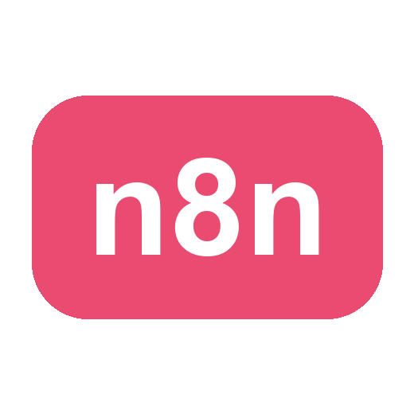
Agentic AI Automation with n8n
TGS Ref No: TGS-2023035977
Conducted by
Tertiary Infotech Academy Pte Ltd
UEN: 201200696W
Version v5

DOCUMENT VERSION CONTROL RECORD
Version Number | Effective Date of Release | Summary of Included Changes | Author
v5 | 1 July 2026 | Aligned the 5 practical tasks (LO1–LO5) to the in-class activities (form→email + storage; Telegram/website AI agent + tool; RAG upload→vector store→agent; webhook/HTTP external data; input guardrail); synced the question paper with the answer key; added the WSQ cover page; standardised the version | Tertiary Infotech Academy Pte Ltd

Agentic AI Automation with n8n
Practical Performance Assessment
Course Code: TGS-2023035977
A: Trainee Information
Trainee Name (as per NRIC): ______________________________________
Last 3 digits and alphabet of NRIC/FIN: ____________________
Date: ____________________
B: Instructions to Candidate
1. This is an individual exercise.
2. This is an open-book assessment.
3. A total of 90 minutes is given to complete this assessment.
4. Submit your answers on the document provided.
C: Practical Problem
Scenario
FryTech Appliances is a fast-growing electronics company selling air-fryer products through e-commerce platforms, retail distributors and corporate/bulk channels. As demand grows, so does the volume and complexity of customer interactions — pre-sales enquiries, post-sales support, warranty claims and logistics. Leadership decides that simple forms and autoresponders are no longer enough and adopts agentic AI-driven workflows, orchestrated in n8n, to improve efficiency, scalability and customer satisfaction. Complete the tasks below, each mirroring an automation you built in class.
Task 1 (LO1):
FryTech receives a high volume of repetitive customer enquiries (pricing, wattage, capacity, warranty). Design and implement an automated customer-enquiry workflow in n8n. It must capture enquiries from a web Form, record the details in a Data Table (or Google Sheets), send a confirmation email to the customer, and notify the sales/support team — using conditional logic where appropriate. Publish the form and turn its URL into a QR code.
Show the screenshot of the n8n workflow in the box below

Task 2 (LO2):
FryTech wants a chatbot that answers team-member and customer questions about product specifications. Design and deploy an AI agent (in Telegram or embedded in a web page) that uses an LLM with memory and at least one tool to answer questions grounded in company data.
Show the screenshot of the n8n workflow in the box below

Task 3 (LO3):
FryTech wants staff to query internal documents (product manuals / IT-Support FAQ / policies) in natural language. Build a Retrieval-Augmented Generation (RAG) workflow: users upload documents which are embedded and stored in a vector store, and an AI agent retrieves the most relevant chunks and answers strictly from them.
Show the screenshot of the n8n workflow in the box below

Task 4 (LO4):
FryTech must integrate with external systems. Build a workflow that either (a) uses a Webhook to receive data from an external web page and respond to it, or (b) uses an HTTP Request to query an external API (e.g. market or news data) and use the result. When run, show the data is received/queried correctly.
Show the screenshot of the n8n workflow in the box below

Task 5 (LO5):
FryTech must secure its AI agent against prompt injection and data leaks. Build a guardrail that protects the agent: an input guardrail that classifies each message ALLOW/BLOCK before the agent (and, optionally, an output guardrail on the reply, or a human-in-the-loop approval step).
Show the screenshot of the n8n workflow in the box below

______________________________________________________________________________
For Official Use Only
Candidate has successfully completed all PP tasks and can explain the overall functions and features used to achieve them.
Grade: _______ (C / NYC)
Assessor Name: __________________________ Assessor NRIC: ________________
Date: ________________________ Signature: ____________________

